How Tax Rate is Determined
An employer’s tax rate is determined based on:
- Experience rating
An employer’s UI benefit ratio is computed by dividing the employer’s experience rate by the amount of taxable wages paid to employees in the prior three (3) fiscal years ending June 30. An employer’s Experience Rate is the dollar amount of unemployment insurance benefits paid to former employees that are charged to an employer's account.
Calculation with the Executive Order
An employer’s 2021 tax rate will be calculated based on their pre-pandemic experience by excluding fiscal year 2020 and instead use the experience from the three (3) fiscal years of 2017, 2018, and 2019:
Fiscal Year | Fiscal Year Period in Fiscal Year
2017 | July 1, 2016 - June 30, 2017
2018 | July 1, 2017 - June 30, 2018
2019 | July 1, 2018 - June 30, 2019
Calculation without the Executive Order
An employer’s tax rate will also be calculated without the Executive Order to ensure employers receive the lowest tax rate they are entitled to. This rate will use the experience from the three (3) fiscal years of 2018, 2019, and 2020:
Fiscal Year | Fiscal Year Period in Fiscal Year
2018 | July 1, 2017 - June 30, 2018
2019 | July 1, 2018 - June 30, 2019
2020 | July 1, 2019 - June 30, 2020
Each employer will receive the lower of the two rates identified on the rate notice. Please note that if an employer’s contribution rate is the same with the Executive Order and without the Executive Order, the employer’s rate will be determined with the Executive Order. This means that the employer’s contribution rate will be calculated based on fiscal years 2017, 2018, and 2019.
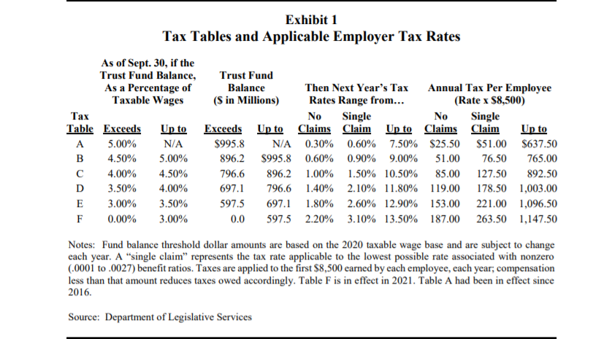
- Balance of the Unemployment Insurance Trust Fund

Impact of the RELIEF Act
- While the RELIEF Act does reduce each individual employer’s tax burden for calendar year 2021 by non-charging for benefits awarded during the COVID-19 pandemic, employers will still see an increase in their 2021 tax rate as the state moves from tax Table A to tax Table F due to the decreased balance of the Unemployment Insurance Trust Fund (“Trust Fund”).

- Due to the Governor’s Executive Order waiving charging of COVID-19 UI benefits, your 2021 tax rate will be calculated based on your pre-pandemic experience by excluding the 2020 fiscal year and, instead, using the three fiscal years of 2017, 2018, and 2019. All chargeable benefits paid to former employees from July 1, 2019, to June 30, 2020, will not impact your tax rate for 2021.
- Since the beginning of the COVID-19 pandemic, over $1.5 billion in benefits have been awarded from the Trust Fund. Based on the balance of the Trust Fund, the state will move from tax Table A, which has a tax rate range from .3% - 7.5%, to tax Table F, which has a tax rate range from 2.2% - 13.5% under state law. Due to the change in the applicable tax table, employers will see an increase in their tax rate for calendar year 2021.
- For example: An employer with a benefit ratio between .0163 and .0189 in Table A had a rate of 2.10%. But, in Table F, the rate for that same benefit ratio will be 4.90%. Without the RELIEF Act, an employer’s benefit ratio might have increased based on their pandemic experience, so their tax rate would be even higher than 4.90%.
Forecast for Future Years
- On March 31, 2021, the Governor announced that $1.1 billion in federal funds available to the State under the American Rescue Plan Act of 2021 would be allocated for UITF. MDL estimates revenue from Table F contributions in calendar 2021 at approximately $863 million, after adjusting for the provision in Chapter 39 of 2021 (the RELIEF Act) that allows for the noncharging of pandemic claims. With the infusion of $1.1 billion in federal funds, MDL estimates that the State will be able to pay off its loan, resulting in a year-end balance of approximately $894 million, and trigger use of Table C for calendar 2022.

